Circle the Correct Answer
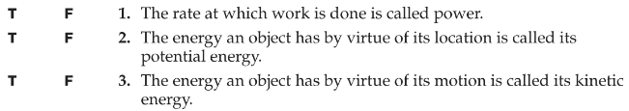
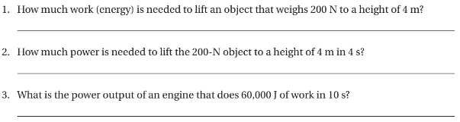
4. The block with mass 50 kg, is being pushed up along the incline with constant velocity. Ignore friction.
a) How much work is done by the gravity on the ice block? Positive or negative work?

b) How much work is done by the person on the ice block? Positive or negative work?

c) How much force is needed to push the block up the incline?
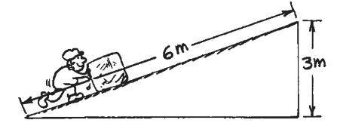

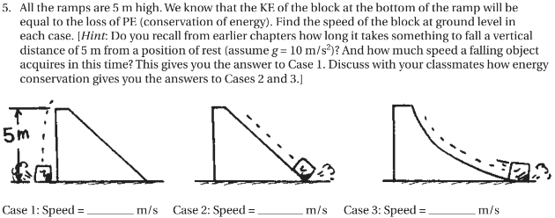

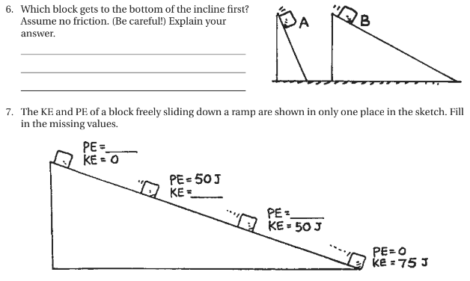
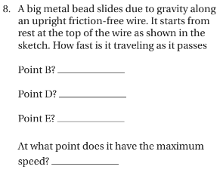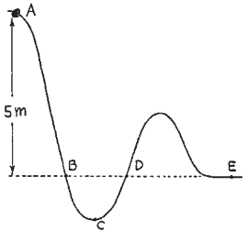
9.
